Douglas College

ECON1150-005

Principles of Microeconomics

Assignment #3

Students: Dawu, Kajol, Hug Nam Le

1. Chapter 6, Problem #10.

a)

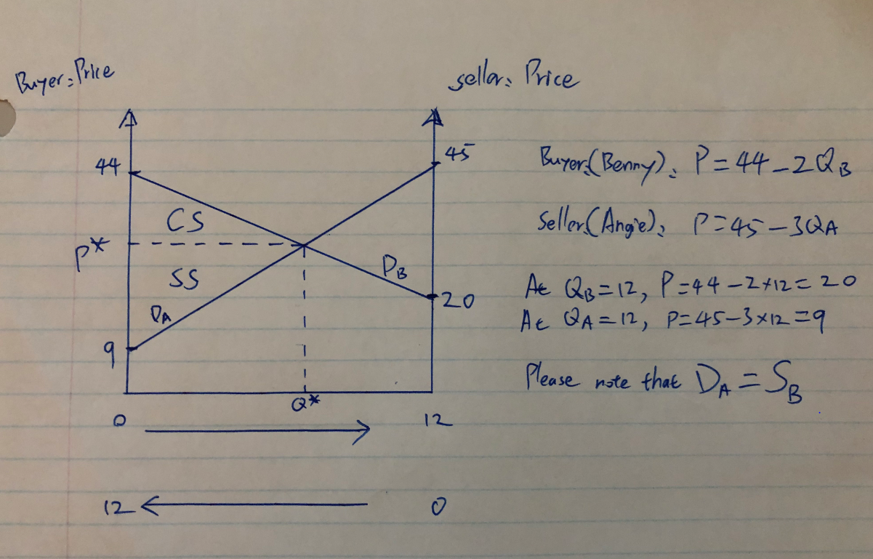

b)

Angie’s demand curve is the supply curve for Benny. The intercept of two demand curve is the equilibrium.

Before the trade, Angie has 12 cookies, so QA=12, MVA = P = 45-3*12 = 9 .

For Benny, he has 0 cookies, so QB=0, MVB = P = 44-2*0 = 44.

c)

First, we need to find the supply curve function for Benny.

SB: P = 9 + (45-9)/12 *QB => P = 9 + 3QB

DB:P = 44 - 2QB

After trade, at P*, Angie and Benny has the same marginal value, which means MVA = MVB.

Therefore: 44 - 2QB = 9 + 3QB  => 5QB = 35 => QB = 7.

QA = 12 - 7 =5

After trade Angie has 5 cookies, Benny has 7 cookies.

The marginal value for both Angie and Benny after trade: MVA = MVB = P* = 44 - 2*7 = 30

d)

Consumer surplus and seller surplus are the area of the corresponding triangle in the graph

Q* = QB = 7

CS = 1/2 * (44-30) * 7 = 49

SS = 1/2 * (30-9) * 7 = 73.5

2.

a)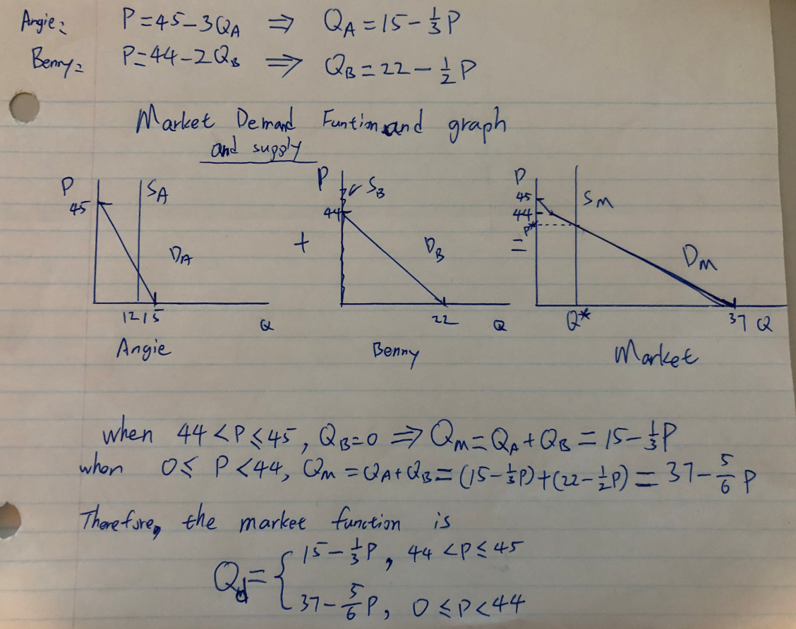

The market supply function is Qs = 12

b)

At market equilibrium, Qd = Qs = 12

=> 37 - 5/6 x P* = 12 => Market equilibrium price P* = 30

Market equilibrium quantity Q* = Qd = Qs = 12

c)

For Angie, QA = 15 - 1/3 * 30 =5, Angie consumes 5 cookies.

For Benny, QB = 22 - 1/2 *30 = 7, Benny consumes 7 cookies.

d)

7 cookies are traded, since Angie had 12 before the trade. Angie sells 7 cookies to Benny.

e)

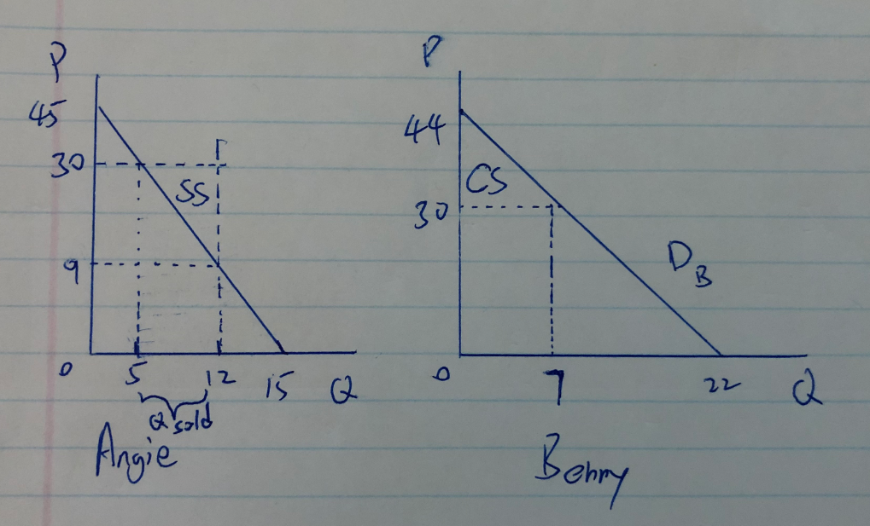

CS = (44-30) * 7 / 2 = 49

SS = (30-9) * 7 /2 = 73.5.

3. Chapter 6, Problem #8

a)

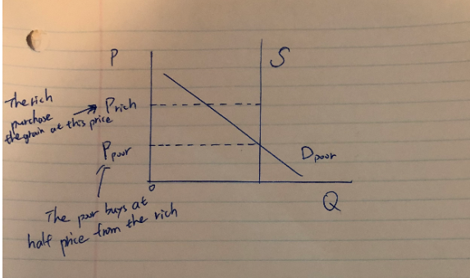

In this case, both the initial supply and new supply curve are the same vertical curve because of bad harvest(no production). The rich buys all the grain then sell them all to the poor.

b)

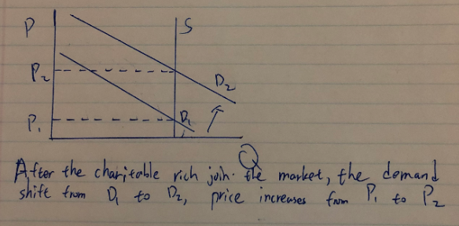

When the charitable rich joins the market, there is a increase in demand, which leads to an increase in price.

c) Before the charitable rich joins the market, the poor benefit from the scheme where they can purchase the grain at half price. But after the the charitable rich joins the market, the price pf grain has raised, only the people who can afford the grain will survive.

1. Chapter 7, Problem #12.

I should make another dessert.

I’ve already spent money on the buttermilk and I would not like to drink the buttermilk, how much the buttermilk cost doesn’t matter anymore . It is sunk cost, it is unavoidable. People should base their decisions on avoidable cost, not sunk cost. The opportunity cost (avoidable cost) here is the “other ingredients” for another dessert, which is $2.50. As I value the dessert for $2.70, which is higher than the opportunity cost. I should make the desert.

Please note that this is based on the assumption that if I don’t use it to make another dessert, then I have no other use for the remaining half pint of the buttermilk other than waste it (no value, sunk cost).

1. Chapter 7, Problem #14.

In order to build gas stations in downtown, they will give up on other buildings, and the alternative buildings have higher value in downtown, which means the opportunity cost is higher for gas stations.

Even if the gas stations have good business in downtown, the value it brings is still low compare to the land’s alternative uses. Besides, the rent in downtown is higher compare to other places, thus the profit gas station brings can be even lower.

1. Chapter 7, Problem #20.
2. This is not true. Even if Bruce doesn’t use his basement for bookkeeping, he can still use it for something else, for example, rent it out. He will need to give up the basement’s highest alternative use in order to run the bookkeeping at home. There is still opportunity cost.
3. In terms of economic, no. The opportunity cost for running bookkeeping is $55000, which is already higher than the income ($48000) it brings.
4. In this case, the value bookkeeping brings to him is $48000+$10000=$58000, which is higher than the opportunity cost of $55000. If we ignore the accounting cost here, his bookkeeping business is profitable .
5. Chapter 7, Problem #26.

|  |  |  |
| --- | --- | --- |
|  | Sam | Linday |
| OC of Oats | 0.33 Shirt/Oat | 0.5 Shirt/Oat |
| OC of Shirts | 3 Oats/Shirt | 2 Shirts/Oat |

Sam has the comparative advantage in producing Oats.

Linday has the comparative advantage in producing Shirts.

b)

The cost of producing one unit oats for Sam is 100/300=0.33 shirt.

The cost of producing one unit oats for Lindsay is 75/150=0.5 shirt

c)

According to comparative advantage, Lindsay should produce shirts first. 100 shirts is produced means Lindsay spends one day to produce the first 75, and Sam produced the rest 25 shirts.

Therefore, Sam can produce 300* (100-25)/100 = 225 oats.

(100-25)/100 is the number of days Sam produces oats, since he produced 25 shirts first.

d)

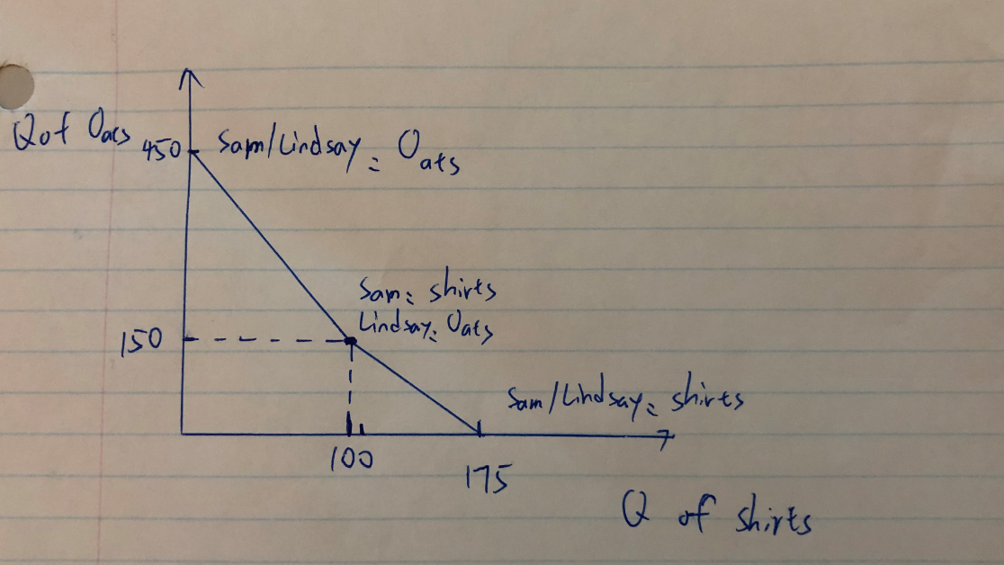

Production possibility curve assuming they specialize according their comparative disadvantage(I don’t why they want to specialize disadvantage first, but this is how the question asks), Sam prioritizes in producing shirts, and Lindsay prioritizes in producing oats.

8. Chapter 7, Problem #28.

The reason why this is a fallacy is because that the $300 can be spent on something else. Maybe the $300 can be spent on a bicycle, that would also bring job opportunity to people, and that job opportunity might be even more preferable compare to glazier. There is always job opportunity, but in order to get some, we will need to give up on others. Because the “window is broken”, we are more limited what job we can have on the market, which can lead to an increasing in opportunity cost for the market.